Thermostat User Guide
Cuarto – Shasta & Yosemite Halls

Our Cuarto Res Halls, Yosemite and Shasta, are equipped with LG Thermostats. These thermostats provide increased energy efficiency by monitoring room occupancy and adjusting room temperatures accordingly based on pre-set temperature limits. All thermostats should be in Auto mode. Bedroom thermostats have a dual setpoint range. Residents can select a comfortable temperature up to 72 degrees in winter or down to 68 in summer. Residents may also choose to turn off their unit and only run the fan. The system fan speed will take precedence over user selected speed if higher speeds are necessary to provide sufficient heating/cooling.
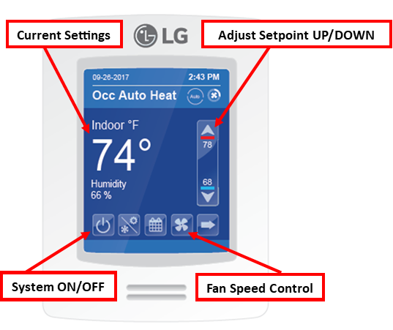
For maximum efficiency and increased energy savings, these LG thermostats are constantly monitoring occupancy in each room. While in Auto mode, if a resident is away from their room for more than 30 minutes, the system will react by reducing heating and allowing a temperature drop of no more than 6 degrees from the setpoint (or whatever it can make-up in 12 minutes). Once a resident returns the system will return to the desired setpoint and maintain that setpoint within 2 degrees as long as the room remains occupied. If a resident is away from their room for more than 48 hours, the system will react by reducing heat and allowing a temperature drop of no more than 12 degrees from the setpoint (Not lower than 58 degrees or whatever it can make-up in 30 minutes). Once a resident/guest returns, the system will return to the desired setpoint and maintain that setpoint within 2 degrees if the room remains occupied.

Thermostat Baseline:
- Thermostat should be in Auto mode.
- Fan should be in Auto mode.
- Residents should be able to turn their unit On or Off from the thermostat.
- Thermostats should always have a temperature range between 68 and 72 degrees
- Tap the Mode button after tapping the Up or Down arrows to change between the cooling or heating setpoints on your thermostat.
Room is Too Cold:
- Has the room been unoccupied for an extended amount of time?
  - Once occupied, allow the room up to 12 minutes to meet the desired set-point.
  - If the room was unoccupied for the previous 48 hours, this could take up to 30 minutes.
- Are the windows open?
  - If outside temperatures are colder than inside temperatures, close all windows to allow maximum efficiency.
  - If outside temperatures are warmer than inside temperatures, open windows to allow increased heating.

If the above actions do not resolve the problem, please submit a service request on-line (Academic Year Residents and/or Staff). Contact your respective Area Service Desk if immediate response is required.



